Белорусский государственный технологический университет
Факультет информационных технологий
Кафедра программной инженерии

Лабораторная работа 8
По дисциплине «Основы Алгоритмизации и Программирования»
На тему «Полустатические структуры данных: очереди»

Выполнил:
Студент 1 курса 6 группы
Качинскас Вацловас Вацловович
Преподаватель: асс. Андронова М.В.
2023, Минск

Создать очередь для символов и функции для ввода, вывода и определения размера очереди. Ввести символы с экрана в очередь. В случае совпадения вводимого символа с последним элементом очереди удалить первый элемент.

main.cpp
#include "Queue.h"

const char menu[] = "\t1-input\n\t2-clear\n\t3-output\n\t4-save\n\t5-load\n\t6-func\n\t0-exit\n";

void main()
{
Queue* begin = nullptr;//pointers for queue
Queue* end, * current;
current = new Queue;
char choise;
int size;
cout << "Enter the maximum size of a queue: ";
cin >> size;
char element;
cout << "Enter the first element of a queue: ";
cin >> element;
current->data = element;
current->next = nullptr;
begin = end = current;
int controll_size;//max size

do {
char element_del = end->data;
cout << "1-Form queue" << endl;
cout << "2-Print elements" << endl;
cout << "3-Delete elements" << endl;
cout << "4-Determine the size of a queue" << endl;
cout << "5-Clear console" << endl;
cout << "0-Exit" << endl;
cin >> choise;
while (!(choise >= '1' && choise <= '6')) {
cout << "Invalud input!Try again: ";
cin >> choise;
}
int choise_sw = choise - '0';//convert char to int
switch (choise_sw) {
case 1:
int curr_ammount;
cout << "How many elements would you like to insert: ";
cin >> curr_ammount;
if (DetermineSize(begin) == size) {
cout << "The queue is full" << endl;
}
else {
if (DetermineSize(begin) + curr_ammount <= size) {
cout << "Able to insert all the elements" << endl;
for (int i = 0; i < curr_ammount; i++) {
cout << "Enter the element: ";
cin >> element;
Push(&begin, &end, element);
}
}
if (DetermineSize(begin) + curr_ammount > size) {//if the required ammount is bigger than a free place
int able_to_fit = size - DetermineSize(begin);
cout << "Able to insert only " << able_to_fit << " elements" << endl;
for (int i = 0; i < able_to_fit; i++) {
cout << "Enter the element: ";
cin >> element;
Push(&begin, &end, element);
}
}
}
break;
case 2:Print(begin); break;//print elements
case 3:
while (Delete(&begin, element_del));//delete element
break;
case 4:cout << "Current size of a queue is " << DetermineSize(begin) << endl;//determine the size of a queue
break;
case 5:system("cls");//clear console
break;
}

} while (choise != '0');//consequence to exit a program
}

Queue.h
#pragma once
#include <iostream>
using namespace std;
typedef char forQueue;
struct Queue
{
forQueue data;
Queue* next;
};

void Push(Queue** begin, Queue** end, char element);
void Print(Queue* begin);
bool Delete(Queue** begin, char element);
int DetermineSize(Queue* begin);

Queue.cpp
#include <iostream>
#include <fstream>//libraries
#include <string>
#include "Queue.h"
using namespace std;

void Push(Queue** begin, Queue** end, char element)
{
Queue* temp = new Queue;
temp->next = nullptr;
if (*begin == nullptr) {//if the pointer is at the start of a queue
*begin = *end = temp;
}
else {
temp->data = element;
(*end)->next = temp;
*end = temp;
}
}

void Print(Queue* begin)
{
Queue* temp = begin;
if (temp == nullptr) {
cout << "The queue is empty" << endl;
return;
}
while (temp != nullptr) {//cycle to print all the elements
cout << temp->data << ' ';
temp = temp->next;
}
cout << endl;
}

bool Delete(Queue** begin, char element)//function to delete a specific node
{
Queue* temp = *begin;
Queue* secTemp = temp->next;
Queue* previous = nullptr;
if (temp != nullptr && temp->data == element) {//if the head node contains the element to be deleted
*begin = temp->next;
delete temp;
return true;
}
while (temp != nullptr && temp->data != element) {//keep searching for the element
previous = temp;
temp = temp->next;
secTemp = temp->next;
}
if (temp == nullptr || secTemp == NULL) {//if the inputed element is not present in the list or is last element
return false;
}
previous->next = temp->next;
delete temp;//free memory
return true;
}

int DetermineSize(Queue* begin)//fucntion to determine current size of a queue
{
int current_size = 0;
Queue* current = begin;
if (current == nullptr) {//if there are no elements
return 0;
}
while (current != nullptr) {//count elements
current_size++;
current = current->next;
}
return current_size;
}

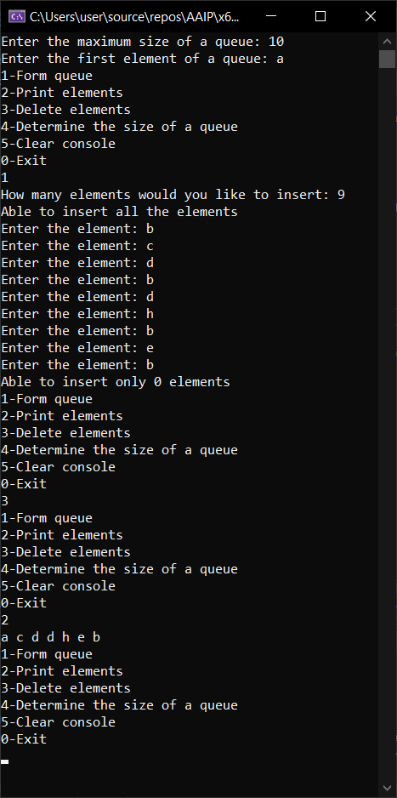
В приложении 1 приведен проект, в котором реализована очередь на основе односвязного списка с приоритетным включением. На основе данного проекта разработать функции, которые предлагается создать в данном приложении.

#include<iostream>
using namespace std;
struct Item
{
int data;
Item* next;
};
Item* head, * tail;
bool isNull(void)
{
return head == NULL;
}
void deletFirst()
{
if (isNull())
cout << "Empty" << endl;
else
{
Item* p = head;
head = head->next;
delete p;
}
}
void getFromHead() //Получение элемента из начала
{
if (isNull())
cout << "Empty" << endl;
else
cout << "Begin = " << head->data << endl;
}
void insertToQueue(int x)
{
Item* p = new Item; //new pointer
p->data = x;
p->next = NULL;
Item* v = new Item; //pointer for new element
Item* p1 = new Item;
Item* p2 = new Item;
int i = 0; //флажок
if (isNull())
head = tail = p;
else
{
p2 = head; p1 = head;
while (p1 != NULL) //пока очередь не закончится
{
if (i == 1)
{
if (x <= p1->data) //число меньше, чем в очереди
{
v->data = x;
v->next = p1;
p2->next = v;
return;
}
p2 = p2->next; // следующее число
}
else
{
if (x <= p1->data)
{
v->data = x;
v->next = p1;
head = v;
return;
}
}
p1 = p1->next;
i = 1;
}
if (p1 == NULL)
{
tail->next = p;
tail = p;
}
}
}
void printQueue()
{
Item* p = new Item;
if (isNull())
cout << "Empty" << endl;
else
{
cout << "Queue = ";
p = head;
while (!isNull())
{
if (p != NULL)
{
cout << p->data << " "; cout << "-> ";
p = p->next;
}
else
{
cout << "(NULL)" << endl;
return;
}
}
}
}
void clrQueue()
{
while (!isNull()) deletFirst();
}

void insertToPriorityQueue(int x, bool isFIFO)
{
if (isNull() || x >= head->data)
{
insertToQueue(x);
}
else
{
Item* p = new Item;
p->data = x;
p->next = head;
head = p;
}
if (!isFIFO)
{
Item* p = head;
while (p->next->next != nullptr)
{
p = p->next;
}
delete p->next;
p->next = nullptr;
}
}
void getFromPriorityQueue(bool isFIFO)
{
if (isNull())
cout << "empty" << endl;
else
{
if (isFIFO)
getFromHead();
else
{
Item* p = head;
while (p->next != nullptr)
{
p = p->next;
}
cout << "Begin = " << p->data << endl;
}
}
}

int main()
{
int i = 1, choice, z; head = NULL; tail = NULL;
do
{
cout << "1 - add element" << endl;
cout << "2 - get element" << endl;
cout << "3 - output element" << endl;
cout << "4 - print" << endl;
cout << "5 - clear" << endl;
cout << "6 - add (LIFO)" << endl;
cout << "7 - get (LIFO)" << endl;
cout << "8 - add (FIFO)" << endl;
cout << "9 - get (FIFO)" << endl;

cout << "0 - exit" << endl;
cin >> choice;
switch (choice)
{
case 1: cout << "Input element: "; cin >> z;
insertToQueue(z); printQueue(); break;
case 2: getFromHead(); break;
case 3: deletFirst(); break;
case 4: printQueue(); break;
case 5: clrQueue(); break;
case 6:
cout << "Input element: ";
cin >> z;
insertToPriorityQueue(z, true);
printQueue();
break;
case 7:
getFromPriorityQueue(true);
break;
case 8:
cout << "Input element: ";
cin >> z;
insertToPriorityQueue(z, false);
printQueue();
break;
case 9:
getFromPriorityQueue(false);
break;

}
} while (choice != 0);
return 0;
}
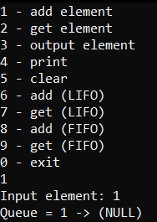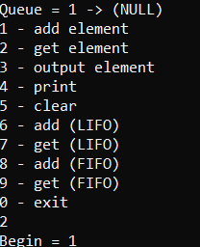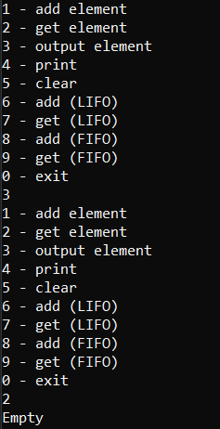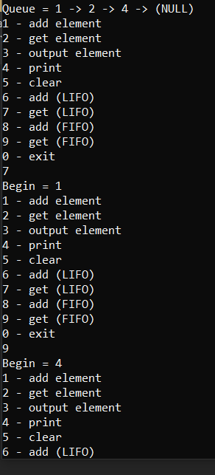

2. Создать очередь с вещественными числами, и заполнить ее с клавиатуры. Выполнить циклический сдвиг элементов в очереди так, чтобы в ее начале был расположен наибольший элемент.
#include <iostream>
using namespace std;

struct QUEUE {
float value;
QUEUE* next;
};

void input_elements(QUEUE** begin, QUEUE** end, float element);
void print_elements(QUEUE* begin);
void sort_queue(QUEUE** begin);

void main()
{
QUEUE* begin = nullptr;
QUEUE* end, * current = new QUEUE;
int queue_size;
cout << "Enter the size of a queue: ";
cin >> queue_size;
float element;
cout << "Enter the first element: ";
cin >> element;
current->value = element;
current->next = nullptr;
begin = end = current;
char choise;
do {
cout << "1-Insert elements" << endl;
cout << "2-Print elements" << endl;
cout << "3-Sort" << endl;
cout << "4-Clear console" << endl;
cout << "0-Exit" << endl;
cin >> choise;
int choise_sw = choise - '0';//convert char to int
switch (choise_sw) {
case 1:
for (int i = 0; i < queue_size - 1; i++) {
cout << "Enter the element: ";
cin >> element;
input_elements(&begin, &end, element);
}
break;

case 2:print_elements(begin); break;
case 3:sort_queue(&begin); break;
case 4:system("cls"); break;
}
} while (choise != '0');
}

void input_elements(QUEUE** begin, QUEUE** end, float element)
{
QUEUE* temp = new QUEUE;
temp->next = nullptr;
if (*begin == nullptr) {
*begin = *end = temp;
}
else {
temp->value = element;
(*end)->next = temp;
*end = temp;
}
}

void print_elements(QUEUE* begin)
{
QUEUE* current = begin;//pointer refering to the sttart of a queue
if (current == nullptr) {//if the queue is empty
cout << "Empty" << endl;
return;
}
while (current != nullptr) {
cout << current->value << ' ';
current = current->next;//move pointer
}
cout << endl;
}

void sort_queue(QUEUE** begin)//function to sort the queue
{
if (*begin == nullptr) {
cout << "Empty" << endl;
return;
}
QUEUE* i, * j;//pointers to interrect with an originall queue
float temp;
for (i = *begin; i != nullptr; i = i->next) {//bubble sort
for (j = *begin; j != nullptr; j = j->next) {
if (i->value > j->value) {
temp = i->value;//change places
i->value = j->value;
j->value = temp;
}
}
}

}

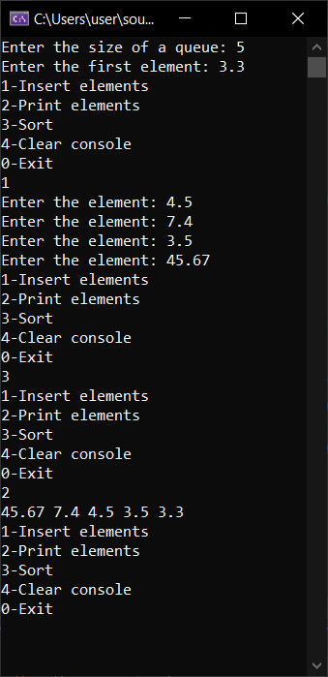
3. Содержимое текстового файла f, разделенное на строки, переписать в текстовый файл g, перенося при этом в конец каждой строки все входящие в нее цифры (с сохранением исходного взаимного порядка, как среди цифр, так и среди остальных литер строки). Использовать очереди.
#include <iostream>
#include <fstream>
#include <string>

using namespace std;

struct MyNumbers//structure for a single linked list
{
char number;
MyNumbers* next;
};
//prototypes
void fromFile(MyNumbers*&, MyNumbers*&);
void pop(MyNumbers*&, MyNumbers*&, int);
void push(MyNumbers*&, ofstream *g);

int main() {//main funciton
MyNumbers* first = nullptr;//pointers to the first and the last element of queue
MyNumbers* end = first;
int choice;
do
{
cout << "?";
cin >> choice;
switch (choice)
{
case 1:
fromFile(first, end);
break;
default:
break;
}
} while (choice != 0);

return 0;
}
void fromFile(MyNumbers*& first, MyNumbers*& end) {//extract elements from file
ifstream f("f.txt");
ofstream g("g.txt");

string baff;
int gg = 0;

while (getline(f, baff))
{
for (int i = 0; baff[i] != '\0'; i++) {
if (!(baff[i] >= '0' && baff[i] <= '9')) {
g << baff[i];
}
else {
pop(first, end, baff[i]);
gg++;
}
}
push(first, &g);
end = first;
g << endl;
}
g.close();
f.close();
}

void pop(MyNumbers*& begin, MyNumbers*& end, int value) {
MyNumbers* p = new MyNumbers;
if (end == NULL) {
p->number = value;
p->next = nullptr;
begin = end = p;
return;
}
p->next = NULL;
if (begin == NULL) {
begin = end = p;
}
else {
p->number = value;
end->next = p;
end = p;
}
}

void push(MyNumbers*& begin, ofstream *g) {

MyNumbers* p = begin;
if (p == NULL) {
cout << "Empty" << endl;
}
else {
while (p != NULL) {
*g << p->number;
p = p->next;
}
}
delete[] begin;
begin = nullptr;
}

